Add a reference Material

After selecting a reference material type (Research Paper, Text Book, Magazine) from the “Add Menu”, the user will be presented with a form to enter the details of the reference material as illustrated below.

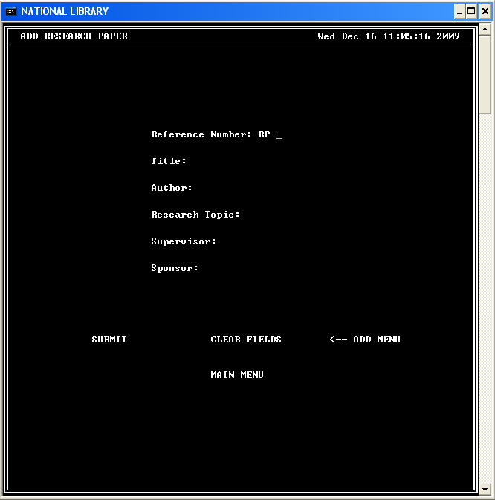

After completing the form:

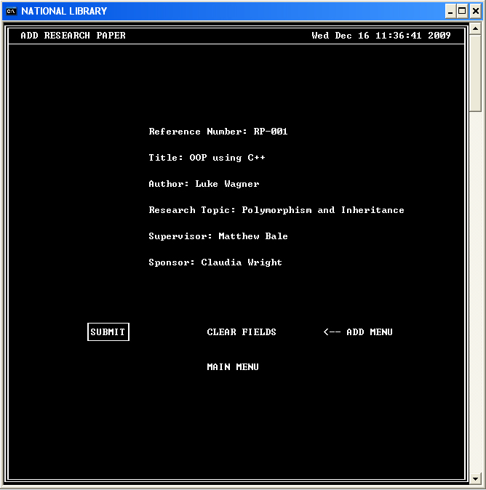

The user will be allowed to “Submit” to save the data, “Clear Fields” which resets the form, “Add Menu” which will take them back to the “Add Menu” where they can choose to add a different Reference Material or “Main Menu” which will take them back to the Main Menu.

Upon selecting “Submit”, the user will be presented with an option of confirming that they want to store the data (SAVE MATERIAL) or “Cancel” as shown below.

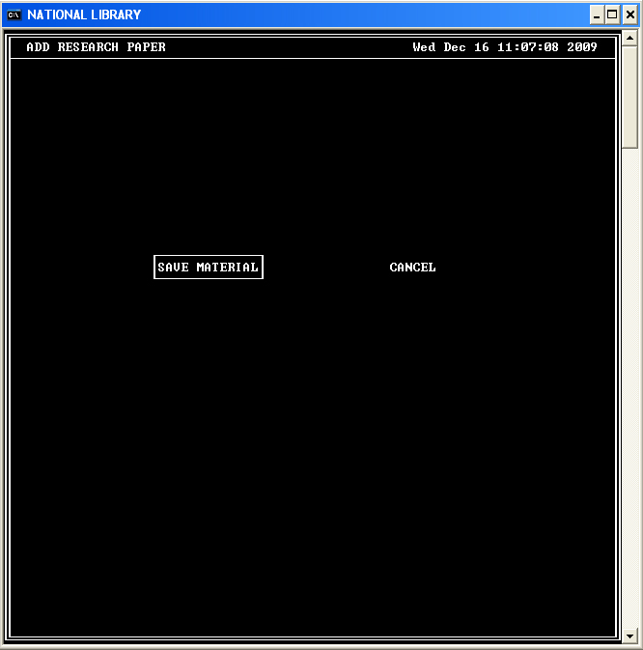

If the user selects “SAVE MATERIAL”, the data will be saved and the following screen will be presented to the user.

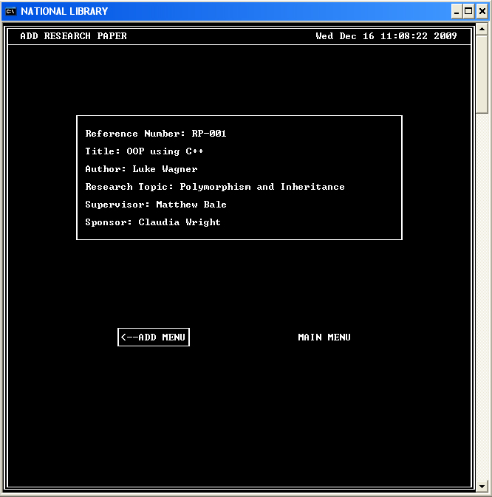

The user will then have the option of returning to the “Main Menu” by selecting “MAIN MENU” or to add another reference material by selecting “ADD MENU”.

